

assessment 1

Evaluate Communicate Business Requirement



VITOR VOLPINI ID: 70406

WELLS INTERNATIONAL COLLEGE

***Task 1: Determine support areas***

Identify information technology (HW and SW) and list the technology in use in D&K Books and consider the following:

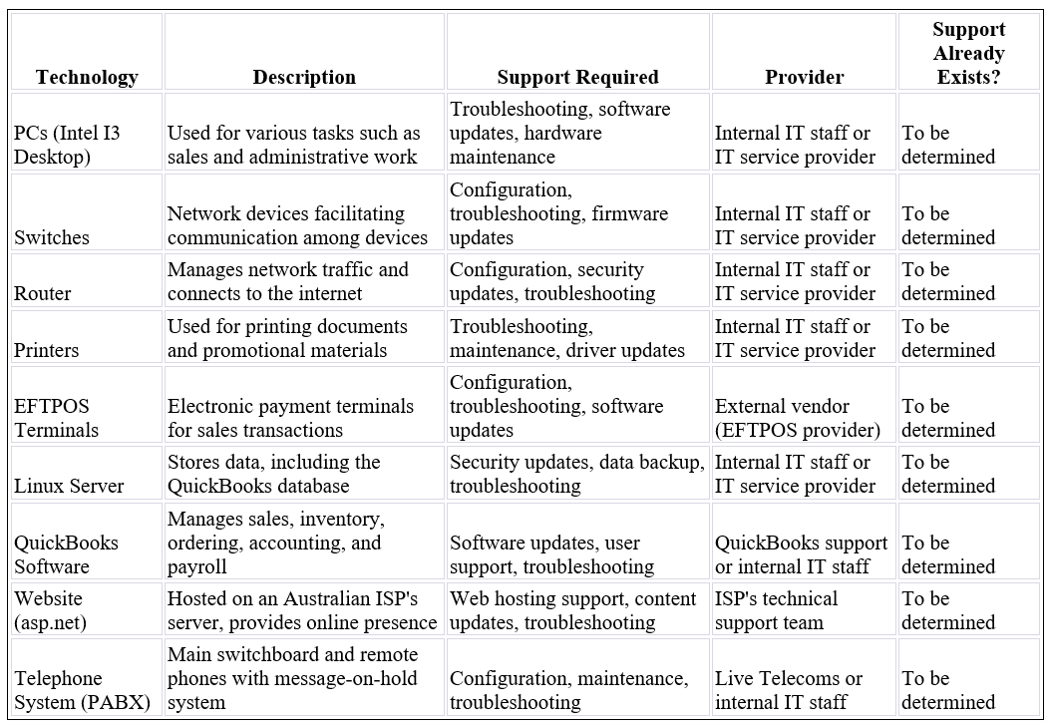

***Task 2: Identify stakeholders***

Identify stakeholders related in D&K Books system.

1. **Mr. Dean Kerr (Owner):** As the owner of D&K Books, Mr. Dean Kerr is a

primary stakeholder with a vested interest in the **bookstore's** profitability and long-term success.

1. **Sales Staff:** The sales team is directly involved in daily

operations, including customer interactions, sales transactions, and

maintaining the bookstore's positive image.

1. **Operations Manager:** The operations manager oversees various aspects

of the business, ensuring smooth operations, inventory management, and

coordination among different departments.

1. **Administrative Officers and Bookkeeper:** These individuals are responsible for administrative tasks,

financial record-keeping, and payroll management.

1. **Marketing Manager:** The marketing manager plays a crucial role in

promoting the bookstore, managing advertising efforts, and attracting customers

through various channels.

1. **IT Staff:** Internal IT staff members are responsible for

managing and maintaining the bookstore's IT infrastructure, including hardware,

software, and network systems.

1. **Customers:** Customers are external stakeholders whose

satisfaction and loyalty are essential for the success of D&K Books. Their

feedback and preferences influence business decisions.

1. **Employees:** All employees, including sales staff,

administrative staff, and IT personnel, are stakeholders with a direct impact

on the bookstore's daily operations and success.

1. **Competitors:** Competing bookstores and businesses in the same

market are stakeholders, as their actions and strategies may impact D&K

Books' market share and competitiveness.

***Task 3: Develop support procedures***

1-) Describe one positive and one negative experience you have had when seeking assistance from a telecommunications company, an ISP or a computer supplier. Your experience may be via telephone, email or even voice recognition.

*Positive Experience:*

Scenario: Customer Support Excellence

You contact your ISP to resolve an issue with your internet connection. The customer support representative is knowledgeable, patient, and effectively guides you through troubleshooting steps. They actively listen to your concerns, provide clear instructions, and offer a solution promptly. The issue is resolved in a timely manner, and the representative follows up to ensure that everything is working smoothly. This positive experience leaves you satisfied with the level of customer service provided.

*Negative Experience:*

Scenario: Frustrating Technical Support

You encounter a problem with your computer hardware and reach out to the manufacturer's technical support line. Upon contacting them, you are transferred multiple times between different support agents, each asking for the same information. The support agents seem unfamiliar with the product and provide conflicting solutions. The entire process becomes time-consuming and frustrating. Eventually, the issue remains unresolved, and you are left dissatisfied with the lack of expertise and coordination within the technical support team.

2-) Using the experiences described above please answer the following questions.

a.What support aspects were professional and/or unprofessional?

b. How long did the support process take?

c. Were the steps logical?

d. Did they solve your problem?

e. Was the call deflected to another area?

Professional:

* The customer support representative was knowledgeable and patient.
* Active listening and clear communication were evident.
* The representative followed up to ensure the resolution was satisfactory.

Unprofessional:

* No unprofessional aspects mentioned in the positive experience scenario.

b. Support Process Duration:

* The support process was efficient and timely. The issue was resolved promptly, and the representative followed up to ensure everything was working smoothly.

c. Logical Steps:

* Yes, the steps taken by the customer support representative were logical. They guided the user through troubleshooting steps in a clear and systematic manner.

d. Problem Resolution:

* Yes, the problem was resolved. The positive experience indicates that the issue was addressed to the user's satisfaction.

e. Call Deflection:

* No, there is no indication in the positive experience scenario that the call was deflected to another area. The customer support representative handled the issue effectively.

***Task 4: Assign Support Personnel***

Here is a table classifying the provided skills into soft skills and technical skills:

* **Soft Skills:** Ability to work under pressure, ability to formulate network and IT policies, ability to write network documentation, and ability to give presentations are classified as soft skills.
* **Technical Skills:** Knowledge of Linux and administration of Windows 2008 Server are classified as technical skills.

***Task 5: Short Answer Questions***

1. Explain the relationship between data, information, and knowledge.

2. What is quantitative data and how can you use it.

3. What is qualitative data and how can you use it.

4. Give an example of how quantitative and qualitative data can be used in conjunction with each other

5. What sort of methods could you use to determine client requirements for a website design and key information sources?

6. Give some examples of client requirements for a website design

1. Relationship between Data, Information, and Knowledge:

* Data: Raw facts and figures without context.
* Information: Data that is processed and organized to have meaning.
* Knowledge: Information that is contextualized, understood, and can be applied.

2. Quantitative Data:

* Definition: Quantitative data represents measurable quantities and can be expressed in numerical terms.
* Usage: It is used for statistical analysis, numerical comparisons, and to identify patterns or trends. Examples include sales figures, revenue, website traffic metrics, etc.

3. Qualitative Data:

* Definition: Qualitative data is non-numeric and deals with qualities, characteristics, and descriptions.
* Usage: It provides insights into attitudes, opinions, and behaviours. Qualitative data is often used in interviews, surveys, or observations. Examples include customer feedback, user experiences, etc.

4. Example of Using Quantitative and Qualitative Data Together:

* Analysing customer satisfaction survey results (quantitative data) alongside comments and feedback (qualitative data) to gain a comprehensive understanding of overall customer sentiment. This combined approach provides both numerical ratings and detailed insights into specific aspects that need improvement.

5. Methods for Determining Client Requirements for Website Design:

* Surveys and Questionnaires: Collect quantitative and qualitative data on client preferences, goals, and expectations.
* Interviews: In-depth conversations to gather detailed qualitative insights.
* Competitor Analysis: Examining competitors' websites for features and design elements.
* Analytics Tools: Utilizing website analytics to understand user behaviour and preferences.
* Focus Groups: Group discussions to gather opinions and preferences.

6. Examples of Client Requirements for Website Design:

* Responsive Design: Ensuring the website functions well on various devices.
* E-commerce Functionality: If the client intends to sell products online.
* User-friendly Navigation: Easy and intuitive navigation for a positive user experience.
* Branding Elements: Consistent use of logos, colours, and imagery.
* Content Management System (CMS): Ability for the client to update and manage content easily.
* SEO Optimization: Implementation of strategies to improve search engine visibility.
* Contact Forms or Customer Interaction Features: Depending on the client's communication needs.

***Task 6: Multiple Choice Questions***

1. 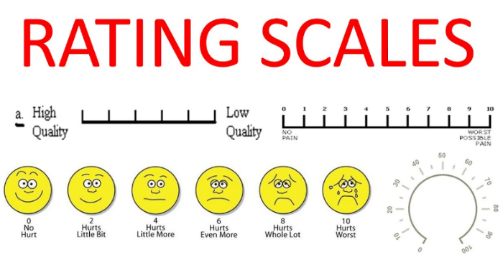Generally, how many points should a rating scale have?
   1. Five
   2. Four
   3. Ten
   4. Somewhere from 4 to 11 points

Comment: In my opinion is ten because it is easier to measure and is the most common rating scale that we generally use.

1. 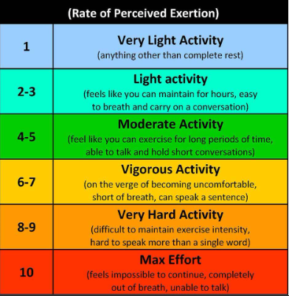What is the problem(s) with this set of response categories to the question “What is your current age?”

* 1-5
* 5-10
* 10-20
* 20-30
* 30-40
  1. The categories are not mutually exclusive
  2. The categories are not exhaustive
  3. Both a and b are problems
  4. There is no problem with the above set of response categories

Comment: Firstly, the categories are not mutually exclusive, as age ranges overlap, potentially causing confusion in data analysis. Secondly, the categories are not exhaustive, as there is no option for individuals above the age of 40, limiting the inclusiveness of the survey.

1. 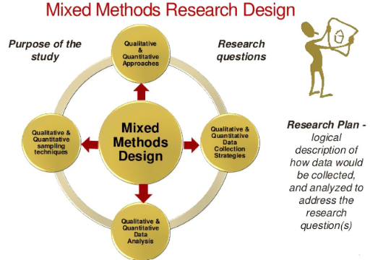You should mix methods in a way that provides complementary strengths and no overlapping weaknesses. This is known as the fundamental principle of mixed research.
   1. True
   2. False

Comment: The fundamental principle of mixed research is not about avoiding overlapping weaknesses but rather about strategically combining qualitative and quantitative methods to capitalize on their complementary strengths.

1. According to the text, questionnaires can address events and characteristics taking place when?
   1. In the past (retrospective questions)
   2. In the present (current time questions)
   3. In the future (prospective questions)
   4. All of the above

Comment: Questionnaires can be designed to address events and characteristics in the past (retrospective questions), the present (current time questions), and the future (prospective questions), depending on the research objectives and the information needed.

1. 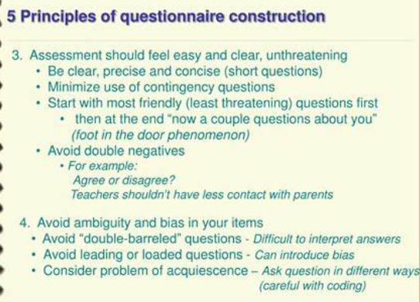Which of the following are principles of questionnaire construction?
   1. Consider using multiple methods when measuring abstract constructs
   2. Use multiple items to measure abstract constructs
   3. Avoid double-barrelled questions
   4. All of the above
   5. Only b and c

Comment: The principles of questionnaire construction include using multiple methods when measuring abstract constructs (a), using multiple items to measure abstract constructs (b), and avoiding double-barrelled questions (c).

1. Which of these is not a method of data collection?
   1. Questionnaires
   2. Interviews
   3. Experiments
   4. Observations

Comment: Experiments are not a method of data collection per se; they are a research method designed to test hypotheses and establish causal relationships by manipulating independent variables and observing the effects on dependent variables.

1. 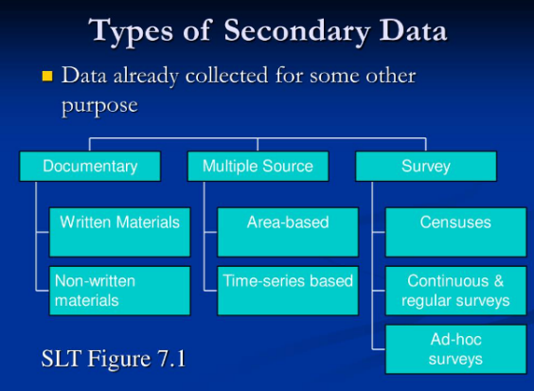Secondary/existing data may include which of the following?
   1. Official documents
   2. Personal documents
   3. Archived research data
   4. All of the above

Comment: Utilizing existing data can be cost-effective and time-saving, but it's crucial to carefully evaluate the quality, relevance, and context of the data to ensure its suitability for the current research objectives.

1. 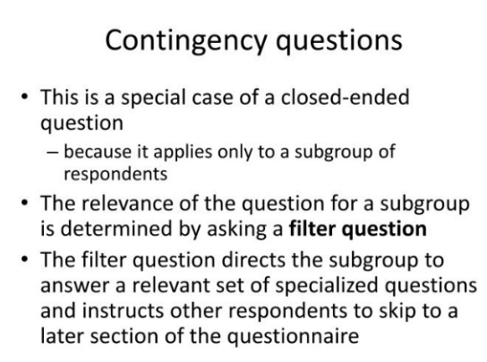An item that directs participants to different follow-up questions depending on their response is called a ____________.
   1. Response set
   2. Probe
   3. Semantic differential
   4. Contingency question

Comment: A contingency question directs participants to different follow-up questions based on their responses. This type of questioning allows for a more tailored and in-depth exploration of specific issues, making the survey or interview process more dynamic and respondent-focused.

1. A graph with different colored triangles

   Description automatically generated with medium confidenceWhich of the following terms best describes data that were originally collected at an earlier time by a different person for a different purpose?
   1. Primary data
   2. Secondary data
   3. Experimental data
   4. Field notes

Comment: Secondary data refers to information that was originally collected by someone else for a different purpose and is being used for a new research or analysis.

1. 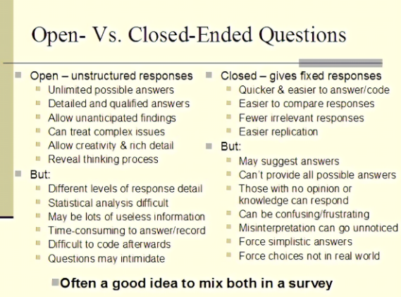Researchers use both open-ended and closed-ended questions to collect data. Which of the following statements is true?
   1. Open-ended questions directly provide quantitative data based on the researcher’s predetermined response categories
   2. Closed-ended questions provide quantitative data in the participant’s own words
   3. Open-ended questions provide qualitative data in the participant’s own words
   4. Closed-ended questions directly provide qualitative data in the participants’ own words

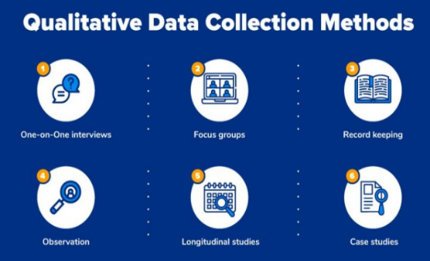Comment: Open-ended questions allow participants to respond in their own words, providing qualitative data that can be rich in detail and nuance.

1. Open-ended questions provide primarily ______ data.
   1. Confirmatory data
   2. Qualitative data
   3. Predictive data
   4. None of the above

Comment: This type of data is exploratory and provides insights into individual perspectives, allowing for a nuanced understanding of the topic under investigation.

1. Which of the following is true concerning observation?
   1. It takes less time than self-report approaches
   2. It costs less money than self-report approaches
   3. It is often not possible to determine exactly why the people behave as they do
   4. All of the above

Comment: Observation is a valuable research method for directly capturing behaviours, but understanding the motivations behind those behaviours may be challenging.

1. 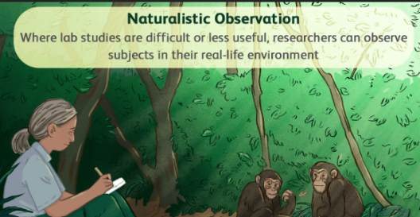Qualitative observation is usually done for exploratory purposes; it is also called ___________ observation.
   1. Structured
   2. Naturalistic
   3. Complete
   4. Probed

Comment: Qualitative observation, often conducted for exploratory purposes, is referred to as naturalistic observation. This approach involves observing subjects in their natural environment without interference or manipulation.

1. A graphic of a glacier and iceberg

   Description automatically generatedWhen constructing a questionnaire, it is important to do each of the following except ______.
   1. Use "leading" or "loaded" questions
   2. Use natural language
   3. Understand your research participants
   4. Pilot your test questionnaire

Comment: It is important not to use "leading" or "loaded" questions when constructing a questionnaire. Leading questions can bias respondents and influence their answers, compromising the validity of the data.

1. A graph with blue lines

   Description automatically generated with medium confidenceAnother name for a Likert Scale is a(n):
   1. Interview protocol
   2. Event sampling
   3. Summated rating scale
   4. Ranking

Comment: A Likert Scale is also known as a "Summated Rating Scale." It is a widely used method for measuring attitudes and opinions through a series of statements or questions.

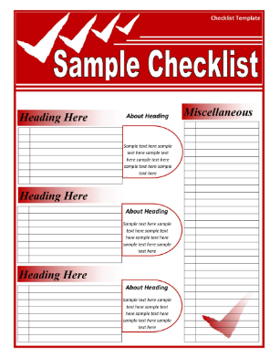

1. Which of the following is not one of the six major methods of data collection that are used by educational researchers?
   1. Observation
   2. Interviews
   3. Questionnaires
   4. Checklists

Comment: Checklists are a tool or a form, not a distinct method of data collection. The six major methods of data collection used by educational researchers typically include Observation, Interviews, Questionnaires, Surveys, Tests, and Case Studies.

1. 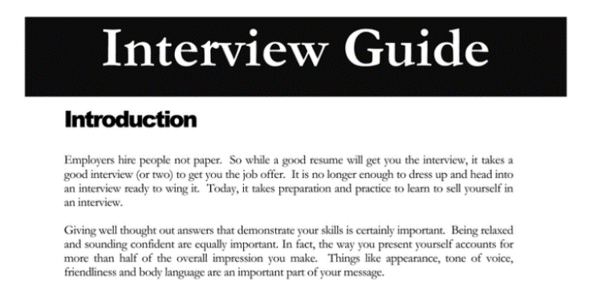The type of interview in which the specific topics are decided in advance but the sequence and wording can be modified during the interview is called:
   1. The interview guide approach
   2. The informal conversational interview
   3. A closed quantitative interview
   4. The standardized open-ended interview

Comment: The interview guide approach involves having specific topics decided in advance, providing a structured framework for the interview. While the topics are predetermined, the sequence and wording can be adjusted during the interview.

1. 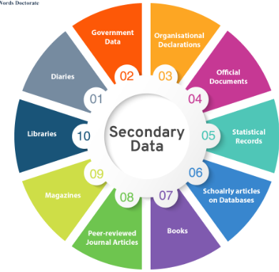Which one of the following in not a major method of data collection:
   1. Questionnaires
   2. Interviews
   3. Secondary data
   4. Focus groups
   5. All of the above are methods of data collection

Comment: Secondary data refers to data that were collected for a purpose other than the current research study.

1. A question during an interview such as “Why do you feel that way?” is known as a:
   1. Probe
   2. Filter question
   3. Response
   4. Pilot

#### Comment: Probes are follow-up questions designed to elicit more detailed or insightful responses from the interviewee. They help to explore and clarify the participant's thoughts or experiences in greater depth.

1. 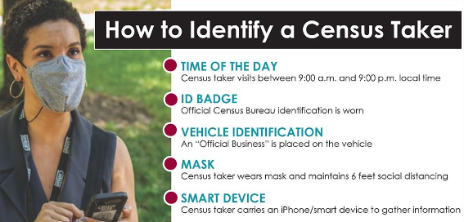A census taker often collects data through which of the following?
   1. Standardized tests
   2. Interviews
   3. Secondary data
   4. Observations

Comment: A census taker typically collects data through interviews. This involves directly interacting with individuals or households to gather information, ensuring a comprehensive and accurate enumeration of the population.

1. 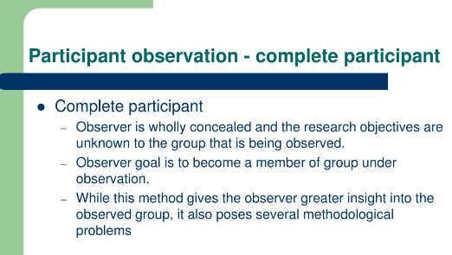The researcher has secretly placed him or herself (as a member) in the group that is being studied. This researcher may be which of the following?
   1. A complete participant
   2. An observer-as-participant
   3. A participant-as-observer
   4. None of the above

Comment: When a researcher actively participates in a group without the group members being aware of the research purpose, it is known as complete participant observation. In this role, the researcher fully engages in the activities and experiences.

1. 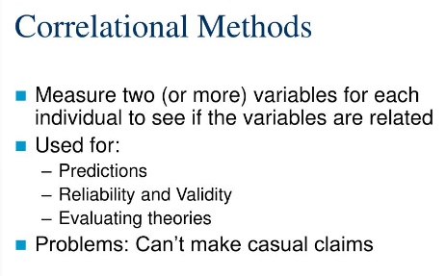Which of the following is not a major method of data collection?
   1. Questionnaires
   2. Focus groups
   3. Correlational method
   4. Secondary data

Comment: The correlational method is a statistical technique used to assess the degree of relationship between two or more variables. It is not a method of data collection but rather a method of data analysis.

1. 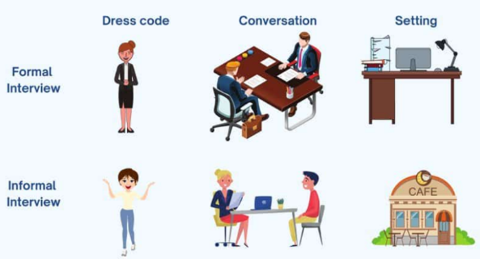Which type of interview allows the questions to emerge from the immediate context or course of things?
   1. Interview guide approach
   2. Informal conversational interview
   3. Closed quantitative interview
   4. Standardized open-ended interview

Comment: An informal conversational interview allows the questions to emerge naturally from the immediate context or course of the conversation. This approach is more flexible, with the interviewer adapting the questions based on the respondent's answers and the flow of the discussion.

1. 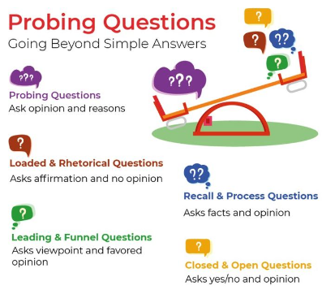When conducting an interview, asking "Anything else?, What do you mean?, Why do you feel that way?," etc, are all forms of:
   1. Contingency questions
   2. Probes
   3. Protocols
   4. Response categories

Comment: Probes are used in interviews to encourage respondents to provide more detailed or clarified responses, helping the interviewer to explore the topic further and gain deeper insights.

1. 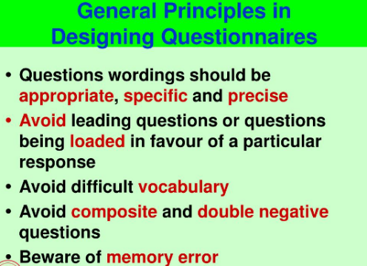When constructing a questionnaire, there are 15 principles to which you should adhere. Which of the following is not one of those principles?
   1. Do not use "leading" or "loaded" questions
   2. Avoid double-barrelled questions
   3. Avoid double negatives
   4. Avoid using multiple items to measure a single construct

Comment: Using multiple items to measure a single construct is not a principle to be avoided; in fact, it is often recommended for improving the reliability of measurements.

1. 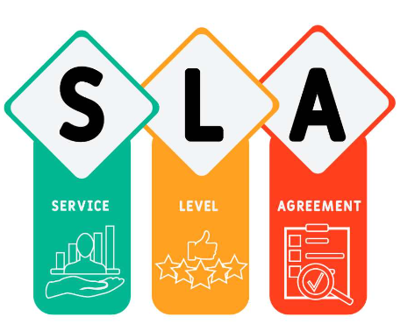A customer-based Service Level Agreement structure includes:
   1. An SLA covering all Customer groups and all the services they use
   2. SLAs for each service that are Customer-focused and written in business language
   3. An SLA for each service type, covering all those Customer groups that use that Service
   4. An SLA with each individual Customer group, covering all of the services they use

Comment: In a customer-based Service Level Agreement (SLA) structure, the SLA is typically organized by service type, covering all customer groups that use that specific service. This approach allows for a more tailored and specific agreement for each service provided.

1. 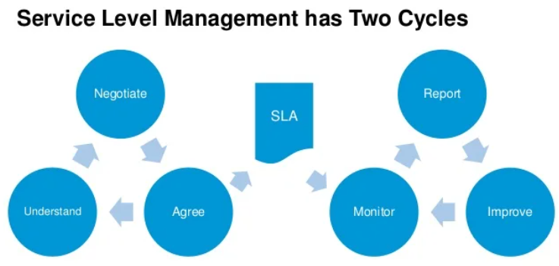Which of the following best describes the goal of Service Level Management?
   1. To maintain and improve IT service quality in line with business requirements
   2. To provide IT services at the lowest possible cost by agreeing with Customers their minimum requirements for service availability and ensuring performance does not exceed these targets
   3. To provide the highest possible level of service to Customers and continuously improve on this through ensuring all services operate at maximum availability
   4. To ensure that IT delivers the same standard of service at the least cost

Comment: The goal of Service Level Management is to maintain and improve IT service quality in accordance with business requirements. It involves defining, negotiating, and documenting the levels of service agreed upon with customers to ensure that IT services align with business needs and expectations.

1. A close up of a document

   Description automatically generatedThe process to implement SLAs comprises of the following activities in sequence:
   1. Draft SLAs, catalogue services, review underpinning contracts and OLAs, draft SLRs, negotiate, agree SLAs
   2. Draft SLAs, review underpinning contracts and OLAs, negotiate, catalogue services,
   3. Review underpinning contracts and OLAs, draft SLAs, catalogue services, negotiate, agree SLAs
   4. Catalogue services, establish SLRs, review underpinning contracts and OLAs, negotiate service levels, agree SLAs

Comment: The typical sequence for implementing Service Level Agreements (SLAs) involves reviewing underpinning contracts and Operational Level Agreements (OLAs), drafting SLAs, cataloguing services, negotiating, and finally agreeing on the SLAs.

1. 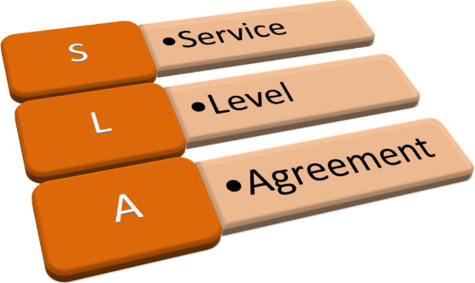Which of the following is an example of a service level agreement (SLA) between information systems support unit and a research unit in the laboratories of a large company?
   1. The maximum response time to get the system operational should it fail.
   2. The minimum ‘up-time’.
   3. The types of information that will be provided as standard.
   4. All of the above.

Comment: SLAs often specify performance metrics, availability targets, and the scope of services to ensure alignment with customer expectations.

1. Close-up of hands shaking

   Description automatically generatedSome organisations bring a degree of formality to the internal customer concept by encouraging (or requiring) different parts of the operation to agree on:
   1. Internal service agreements
   2. Service level agreements
   3. Formal provision agreements
   4. Delivery agreements

Comment: Some organizations formalize the internal customer concept by encouraging or requiring different parts of the operation to agree on Internal Service Agreements. These agreements help define and document the expectations and responsibilities.

